A1.12 Sequence Diagram

|  |  |  |  |
| --- | --- | --- | --- |
| 일자 | Version | 설명 | 담당자 |
| 2011.02.08 | **V1.0** | **Sequence Diagram** | **윤진경** |
| 2011.04.10 | **V2.0** | **Sequence Diagram** | **윤진경** |

목차

a1.12.1 sEQUENCE dIAGRAM2-4

**UC 1. Register account of twitter**

**UC 2. Request a new word to administrator**

**UC 3. Write on wall**

**UC 4. Analyze a statement**

**UC 5. Inform user of their mind**

**UC 6. Check out the feeling**

**UC 7. Import twitter**

**UC 8. Update for DB**

**A1.12 Sequence Diagram**

**UC 1. Register account of twitter**

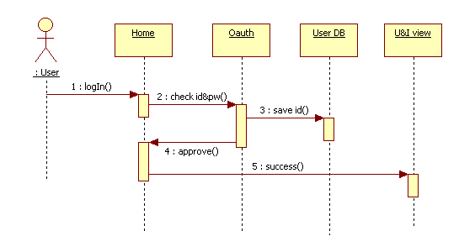

**계정등록 실패시**

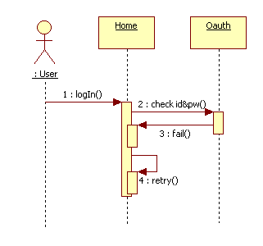

**UC 2. Request a new word to administrator**

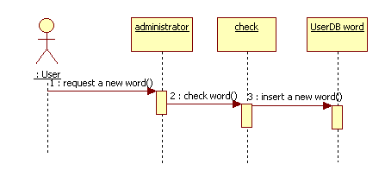

**UC 3. Write on wall**

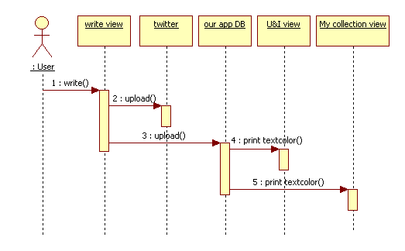

**UC 4. Analyze a statement & UC 5. Inform user of their mind**

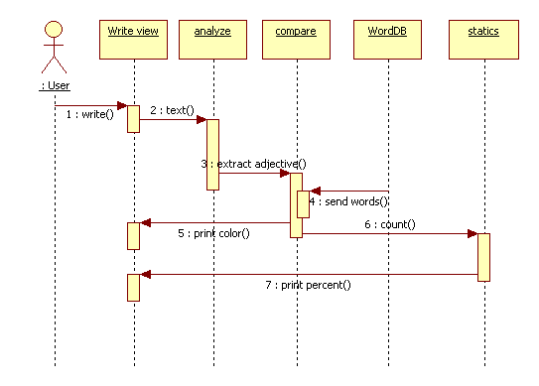

**UC 6. Check out the feeling**

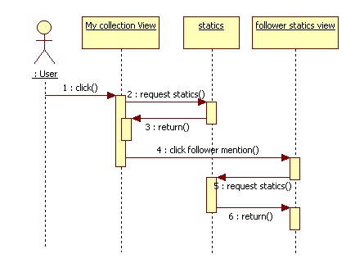

**UC 7. Import twitter**

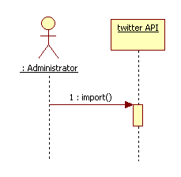

**UC 8. Update for DB**

